1. Program to find the largest of 03 numbers
Exp O/P: Largest = ? using nested if statement, ladder if statement, ternary operator
2. Program to check whether a number is odd or even
3. Program to display first "n" odd numbers
Exp O/P: 1 3 5 7 ......
4. Program to display the even numbers between x & y
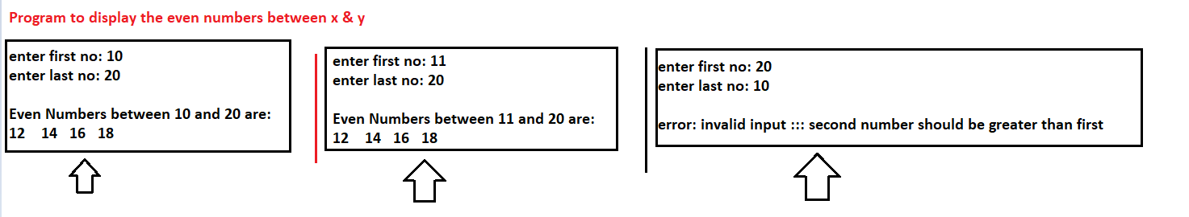
5. Program to reverse a number; For example , if the number is 9835 , then O/P should be 5389
6) Program to find the sum of digits of a number
7) Display the first 15 elements of the following sequences
1 4 7 10 ..
8) Display the first 15 elements of the following sequences
1 2 4 8 ..
9) Display the first 15 elements of the following sequences
0 1 1 2 3 ....

10) Display the following Patterns:
*
* *
* * *
* * **
* * ***

11) Display the following Patterns:
1
1 2
1 2 3
1 2 3 4
1 2 3 4 5
1 2 3 4 5 6
1 2 3 4 5 6 7 8
1 2 3 4 5 6 7 8 9
12)
